DETAILED REPORT: POWER BI ASSIGNMENT

TOPIC : US SHOOTINGS

**Introduction:**

This Project is based on a recent surge in US police killings that has sparked a national conversation on racism, prompting an in-depth examination of the data to uncover underlying patterns and insights.

**The Goal:**

This analysis aims to investigate the relationship between race and police killings in the United States, identifying key trends, disparities, and areas for improvement.

**Dataset Overview**

The dataset was collected over the period of 2015 to 2020. It comprises 4895 rows, representing individual fatalities, with:

- 4673 male victims (95.46%)

- 222 female victims (4.54%)

**Data Exploration**

Using Power BI Desktop, I observed that the dataset was clean and as such I explored and wrote some DAX formulas to help enhance my visualization. Also, the ages of the victims were put in bins and I identified key questions based on columns that sparked curiosity and narrative potential:

**Research Questions:**

1. What is the gender distribution and age categories of the victims?

2. What are the racial backgrounds of the victims?

3. Do geographic locations influence death rates?

4. Are there patterns in officer-involved shooting circumstances especially with the use of their body camera?

5. How do victim characteristics correlate with shots from the police?

**THE FINDINGS**

1. **COUNT OF SHOOTINGS BY GENDER:**

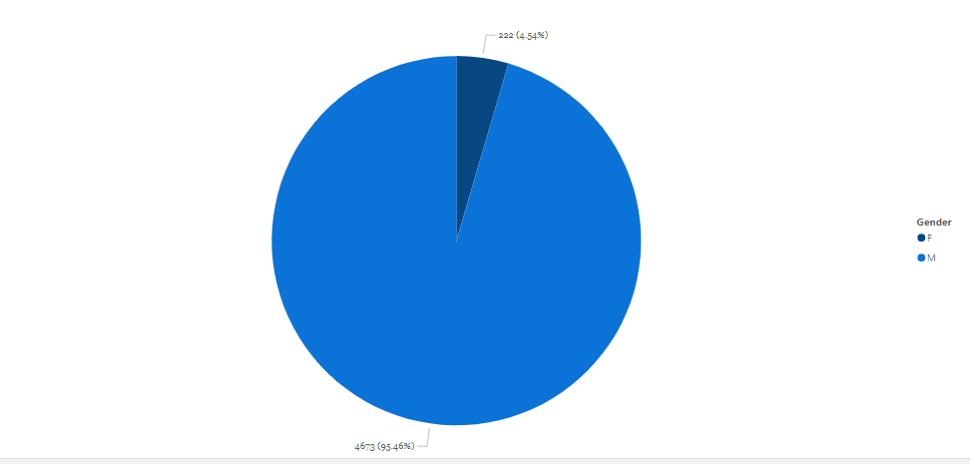

It was observed that out of the 4,895 victims, males formed the majority with a 95.46% and the females were 4.54%

1. **TOTAL NUMBER OF SHOOTINGS ACROSS THE STATES**

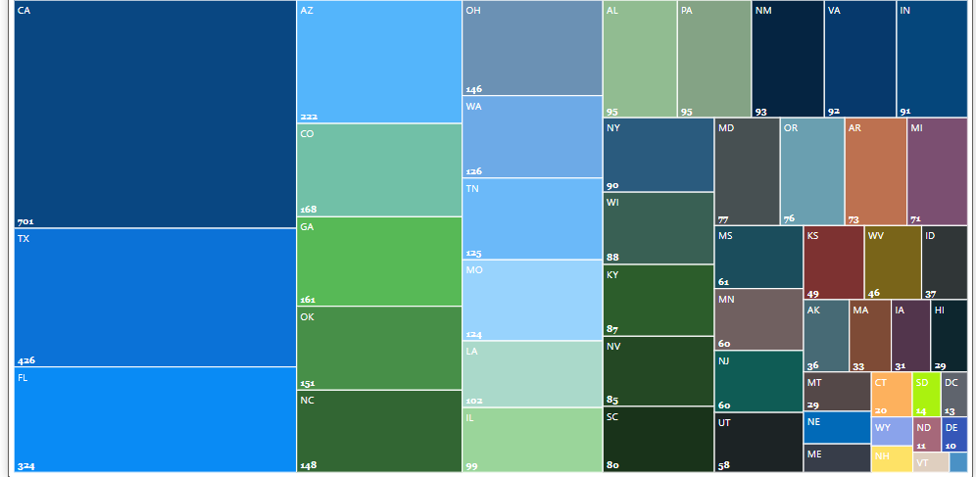

Looking at the deaths recorded across the States, we can see that California recorded the highest shootings of 701, followed by Texas 426 with Rhodes Islands having the least of 4.

California ranks as the second most diverse state in the US in relation to race and presumably this could be a leading factor.

1. **AGE CATEGORY FOR ALL VICTIMS**

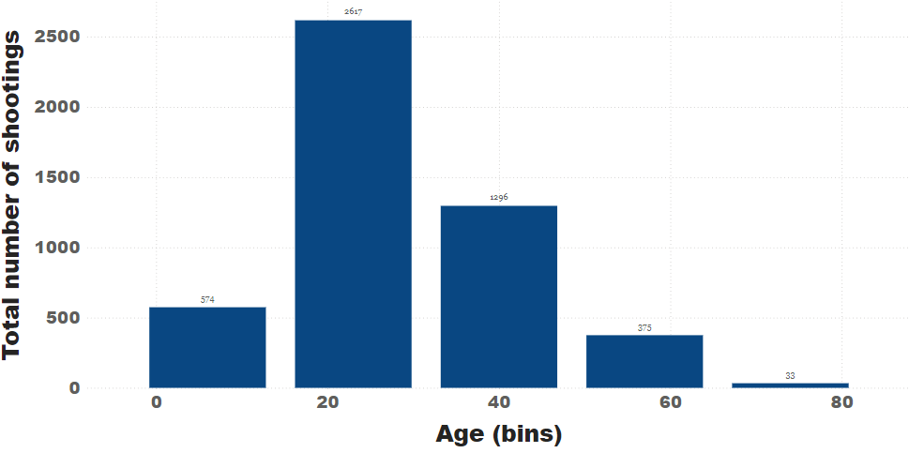

It can be observed that the highest number of victims were found in the age range of 20-39 years whereas age 80 and above recorded the least number of deaths.

1. **TOTAL NUMBER OF SHOOTINGS BY RACE**

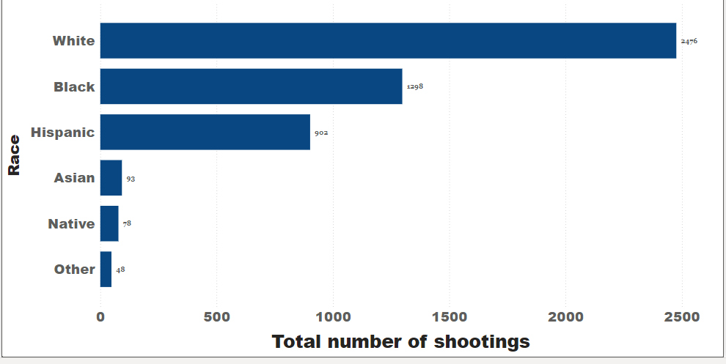

The dataset proved that the white race were the highest victims (2,476) followed by the Blacks(1,298) then the Hispanic(902)

1. **USAGE OF BODY CAMERA BY POLICE DURING SHOOTINGS**

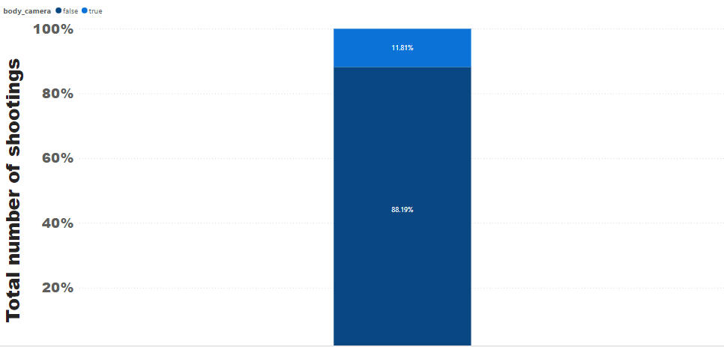

The above visual shows that 88.19% of the time, US Police had their body cameras turned off in these shootings or killing incidents.

1. **DISTRIBUTION OF DEATH PER MOVEMENTS**

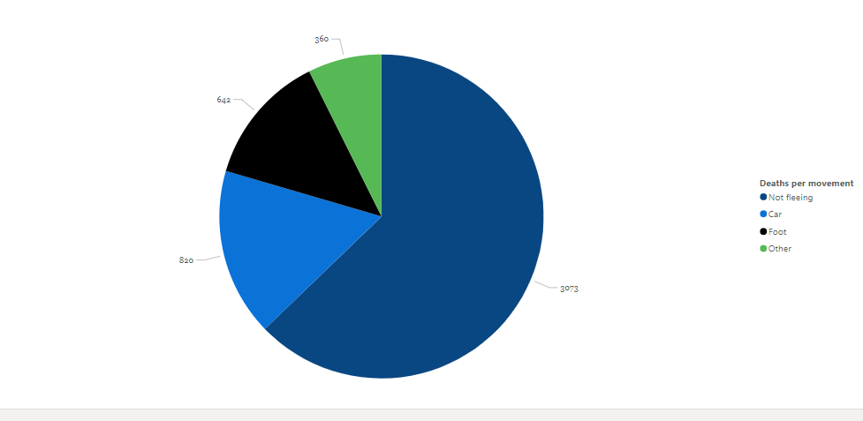

Looking at the distribution per death we observed that 3,073 of the victims were not fleeing at the time they were shot.

..

1. **SHOOTINGS AS PER THREAT LEVELS:**

However, the shootings as per threat levels shows that 3,160 of the victims attacked the Police officers which could probably have led to them being shot.

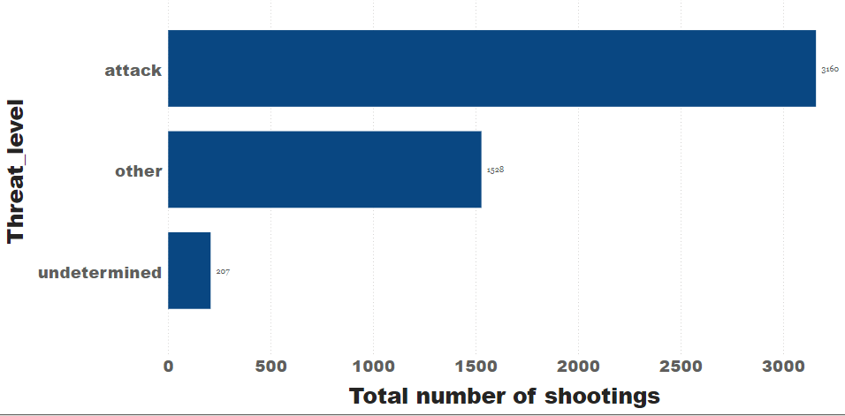

**RECOMMENDATIONS:**

From the above insights we can clearly see that the number of whites shot dead are actually more than all the other races combined. As such we cannot conclude that the killings have racial bias. However, I will suggest that certain areas they can improve upon are the use of body cameras, which must come with a higher form of compulsion to be turned on at all times.

Also, if most victims were not fleeing at the point of being shot then such incidents should be handled better.